Stewarts Special School Palmerstown Mr Toomey
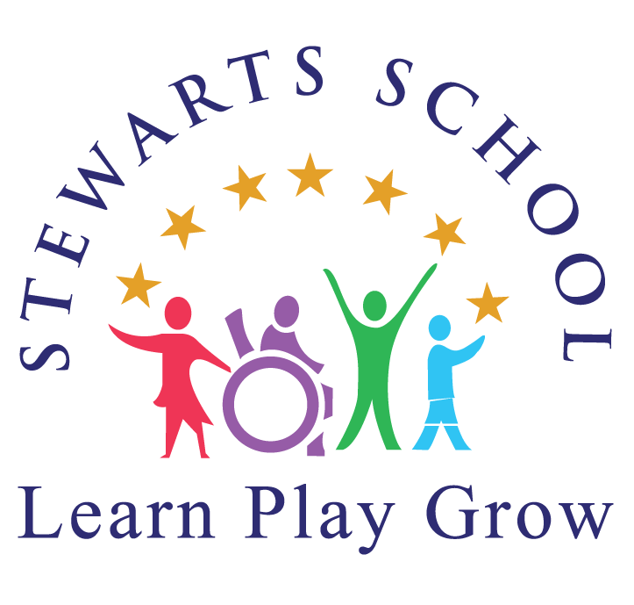
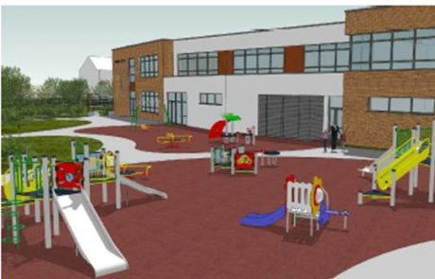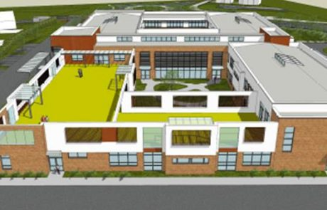
Stewarts School caters for students with moderate, severe and profound
intellectual disabilities.
The school also welcomes any child who, in addition to a diagnosed moderate, severe or profound intellectual disability, has one or more diagnosed additional disabilities (for example, autism, ADHD, dysphasia, epilepsy, etc.).
Stewart’s Special School,
Waterstown Avenue,
Palmerstown,
Dublin 20
Eircode: D20TR62
Phone number: 016518285

Email address: school@stewartscare.ie
Website address: stewartsschool.ie Principal: Mary Carrig

Stewarts school is committed to providing service users with the services that they require, irrespective of their level of need.
Person-centred services will be provided, taking cognisance of the person’s dignity and rights, and based on an assessment of need and the services requested.

Operating from two main sites at Palmerstown, and Balgaddy in South West Dublin, and several satellite residential and day service centres throughout West Dublin and North Kildare, Stewarts provides extensive services to people with an intellectual disability.

Each service user has their own Personal Support Plan (PSP) that outlines their personal goals and individual support needs.

Access to Services / Eligibility Criteria
Early Services
Children with a developmental delay and/or intellectual disability who live within the Dublin / Mid Leinster region can apply for admission to services via a medical referral.
Medical referrals to the Early Services Team will be processed by the Director of Clinical Services, as per Stewarts' Admission to Early Services Policy.

Adult Services
Admissions to Adult Day Services are accepted for persons who have an intellectual disability and live in the Dublin / Mid Leinster region.
Referrals will be processed by the Director of Clinical Services or the relevant Programme Manager and should be accompanied by all relevant reports.

Overview of the School
- Stewarts School caters for students with moderate, severe and profound intellectual disabilities.
- The school welcomes any child functioning within the above range of intellectual disability and that this intellectual disability is her/his primary special educational need.
- The school also welcomes applications for enrolment of any child who, in addition to a diagnosed moderate, severe or profound intellectual disability, has one or more diagnosed additional disabilities (for example, autism, ADHD, dysphasia, epilepsy, etc.).
- The school provides an educational service to children residing within the following areas: Palmerstown, Chapelizod, Ballyfermot, Templeogue, Tallaght, City West, Saggart, Clondalkin, Lucan and Adamstown.
- The school accepts applications from children aged between 4 and 18 each year.
- Applications are treated as applications for particular classes.
- 1.3 The maximum class size in Stewarts School varies from 6 to 8 students, depending on whether the students in the class have moderate or severe/profound needs.
- 8 Classes
- Class sizes may also be smaller depending on the number of students within a class presenting with co-morbid disorders, autism or other additional needs.
- The school has 23 teachers and over 120 students.
- School capacity varies according to the needs of the children we are catering for at a particular time.
- Applicants should note that the availability of a space in the school will be dependent on the level of needs of each Applicant. For example, although there may be two places available in a particular class grouping, if a child is enrolled with severe needs, or if the child requires large or physically bulky equipment, we may be only able to accommodate one child instead of two in that particular classroom.

In the admissions process, consideration will be given to ensure that a
healthy and safe environment for all students and staff prevails and
applications for children who might threaten the safety of the children already enrolled, many of whom are vulnerable by nature of their disability are likely to be refused.
Closing Date for Applications for that particular year of
entry (1st March).

Stewarts School is a special school, it does not have a particular intake group as many mainstream schools do.
At an early stage of the application process, a child is assigned to a particular destination class based on the child’s age, cognitive and adaptive abilities and any other special educational needs of relevance. Class groupings vary from year to year as students leave the school, move to other schools, or leave the catchment area.

Initial School Visit
- Before making any application, the child’s parents/guardians may wish to consider visiting the school so that they will be better able to decide on the suitability of the school for their child.
- If the Board of Management decides to admit/ or not admit a child, a letter will be sent to parents within 21 days of the closing date for applications.
- Parents/guardians will be requested to respond to the offer of a place by a specified date (failure to respond by that date will result in the offer lapsing) and a time will be arranged for them to visit the school to enable the completion of applications to the NCSE for school transport and SNA support, if applicable;
- The placement of a child’s name on a list, however early, does not confer an automatic right to a place in the school.
- The school does not operate its applications process on a first come, first served basis - each application will be considered on its merits and in light of the places available in the 8 different classes in the school.

The school will only consider a child where he/she meets all of the following SIX criteria:
Threshold Criteria for Consideration of Application:
1. The child is in the cognitive range for students with moderate, severe or
profound learning disabilities i.e. has an IQ of less than 50 (as confirmed
by an appropriate professional’s report included in the child’s application)
and therefore, has the ability to benefit from the education and skills
programmes offered in the school;
2. The child is in the adaptive range for a child with moderate, severe or
profound learning difficulties (as confirmed by an appropriate report
included in the child’s application) and therefore has the ability to benefit
from the education and skills programmes offered in the school;
3. The application form was fully completed and included all enclosures
appropriate to the application.
4. The application was received by the Closing Date for applications for that particular year of entry.
5. The child is at least 4 years old and has not reached their 18th birthday on the 1st of September of the year of entry;
6. There is sufficient physical space in the destination classroom and the
appropriate class for that child has not reached full capacity (i.e. that the
class is not oversubscribed).

Parents should note that just because a child is assigned to a particular destination class, this does not mean that there is a vacancy in that class, merely that the destination class is suitable for the child in light of the child’s age, cognitive and adaptive abilities and any other special educational needs of relevance.

On the last of day in June of each year, the Waiting List will cease to operate.
If a child is entered on the Waiting List for a particular academic year, this
will not give them any priority for entry in the academic year commencing
the following September.
A new application for the child will be required for the following academic year even if they are placed on the Waiting List and his/her application will be processed again under the Admissions and Participation Policy.

Curriculum:
Our junior students have access to a broad range of curriculum experiences based on the Guidelines for Teachers of Students with General Learning Disabilities and the Primary School Curriculum.
The students follow the curriculum/ guidelines for the following subjects:
- language and communication
- mathematics
- SESE - history, geography, science,
- visual art,
- drama
- music
- physical education
- social & personal health education.

Our senior students follow the Junior Cycle Framework – Level 1 Learning Programmes.
The programme is tailored to meet the individual needs of our students. The Level 1 Learning Programmes are made up of six Priority Learning Units (PLUs) which explicitly identify and develop the key areas of learning needed to prepare the students for their future lives.
- Communication, Language and Literacy
- Personal Care and Wellbeing
- Being part of a Community
- Numeracy
- The Arts
- Physical Education.

Each student has their own individual education plan which is developed by the student’s class teacher in consultation with parents.
Special needs assistants, nurses and clinicians are consulted as needed.

In an effort to facilitate our students we also use Lámh, PECS and other augmentative communication systems.
Other educational programmes such as TEACCH, Numicon, etc. along with assistive technology such as the iPod touch, iPads, eye-gazes, interactive whiteboards and various switches are also in use.

