Mr Toomey

St Raphael’s Special School
Saint John of God Community Services
Celbridge
Clane Road
Co. Kildare
Eircode: W23F2P5

Principal's name: Kathleen Waldron
Phone number:01 6012476
Email address:straphaelsschool@sjog.ie
Website address:www.sjogliffeyregion.ie/shool-homepage

School for:
Moderate general learning disability, pupils with a severe or profound general learning disability and pupils with an autistic spectrum disorder (ASD).

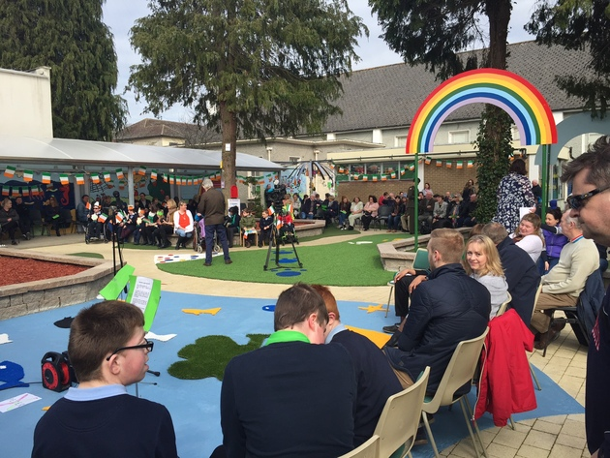
Mr Toomey
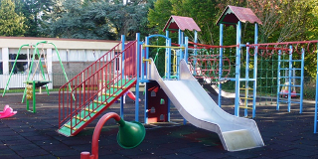
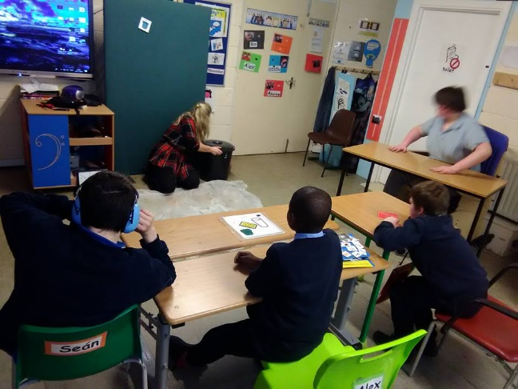
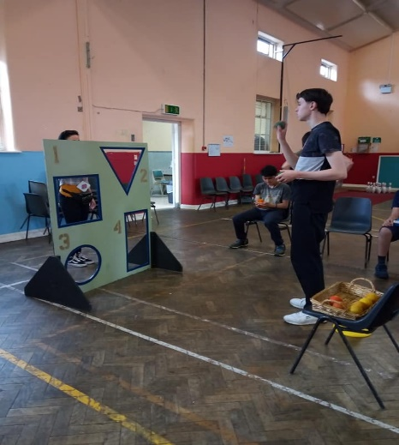

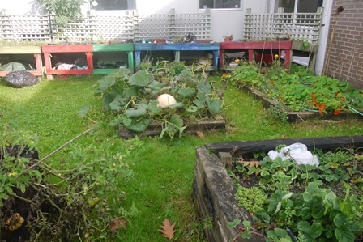
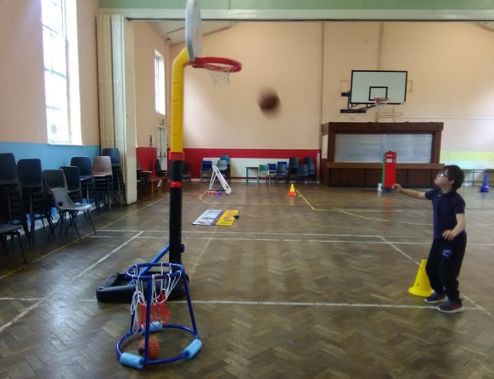
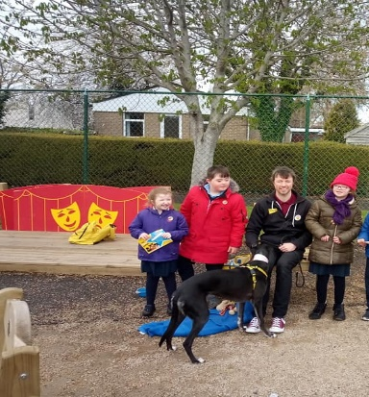

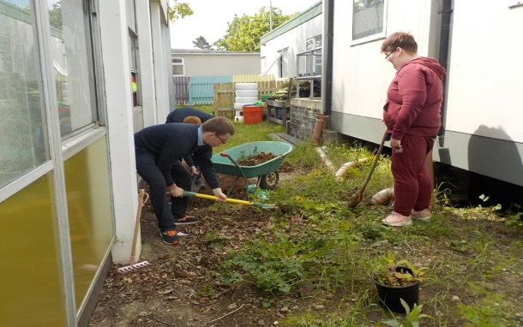

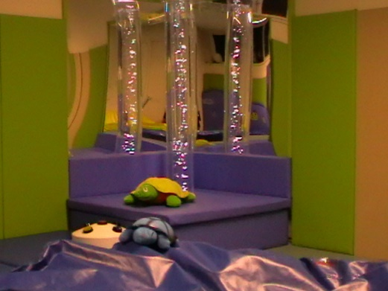

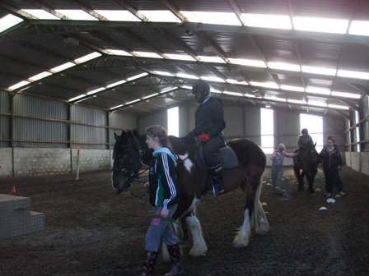

Mr Toomey

General Information
- St. Raphael’s provides education to pupils with a moderate general learning disability, pupils with a severe or profound general learning disability and pupils with an autistic spectrum disorder (ASD).
- A number of pupils attending the school have multiple disabilities.
- 74 pupils, aged between five and eighteen years of age.
- It is a co-educational special school
- We have 12 classes: Four for pupils with severe and profound intellectual disability, two for pupils with moderate intellectual disability and six for pupils within the Autistic Spectrum.
- The school curriculum is based on the Guidelines for Teachers of Students with General, Moderate and Severe and Profound Learning Difficulties.
- Staff – 12 Teachers, 35.5 SNAs and 2 nurses
- Many methods of communication are used, verbal communication using symbols, words, pictures and sentences; communication with the help of technology as well as alternative communication systems
such as the Picture Exchange Communication System (PECS). Sign language is used to communicate in all settings (LÁMH)
- The school has a designated Aistear room
- The school is part of Saint John of God Kildare Services.
- The catchment area cover Celbridge, Leixlip, Lucan South, Maynooth, Rathcoole, Newcastle, Sallins, Prosperous and Clane. Referrals from outside the area are considered on a case by case basis.
- Classes are of mixed gender with 6 or 8 pupils.
- Each class follows a modified curriculum.
- School opens at 9:20am and finishes at 2:50pm.
- In September 2012 ASDAN was introduced to facilitate pupils’ learning in accordance with their
individual ability. ASDAN = Personal Development Programmes (Bronze, Silver and Gold). These offer imaginative ways of developing, recording and certificating a wide range of young people’s personal qualities, abilities and achievements, as well as introducing them to new activities and challenges.
- The school is dependent on grants, teachers and special needs assistants are funded by the Department for Education and Skills.
- School pupils are supported by members of the Network Disability Teams (NDT).
The NDT teams comprise of psychologists, speech and language therapists, social workers, physiotherapists and occupational therapists. Inputs from the various teams are provided in accordance with the assessed needs of each pupil.
- School Starts at 09:10
Morning break 10 minutes
Lunch 12:25-12:55 (Pupils have a hot lunch in school)
- Finishing time is 14:50
- Additional Subjects – Pottery, Drama and cooking
- July Provision is offered in the school as well.

Mr Toomey

School Facilities

- Ball Pool Room
- Our ball-pool room gives pupils a safe and physically supportive environment for adventurous play.

- Play Room
- The playroom has sand and water trays, toy kitchens and dressing up clothes to encourage younger pupils in imaginative and pretend play. There are board games for the older pupils.

- Playground
- We have an outdoor playground and classes are timetabled to use this throughout the week.
Sensory Room
- Our multi-sensory room provides stimulation, light and texture activities which aid development, particularly for children with sensory impairments.
Sport and Recreation
- Our pupils can use all the sports facilities on St Raphael’s campus that support the physical education programme within the school. These include: swimming pool, fitness room, Bocce room, and sports hall for basketball, soccer, motor activities and other sports.
- Pony riding sessions are available to pupils in the School. These are organised in partnership with Riding for the Disabled Ireland.
- Pupils also have opportunities to enter local and national sporting competitions, and can participate in Special Olympics events at a regional, provincial, national and international level.
Tuck Shop
- The tuck shop opens once a week. It helps to promote independence, social skills, numeracy, responsibility and healthy eating. Pupils are also given opportunities to assist in the tuck shop.

The School Garden
- The school garden area has a section where pupils plant and grow vegetables.

Social Outings
As part of their individual programmes pupils in St Raphael's School go on social outings. These may be to
local parks, to the shops, for walks around the grounds of St Raphael's campus or to the Maple Room. The
outings support our pupils' social integration into the communities in which they live.
Trips taken to the zoo and Clonfert Pet farm.

Mr Toomey

Referral Procedure
- Referrals are accepted from parents/guardians, school principals, playgroup leaders, psychologists, Department of Education and Skills, Health Services Executive (HSE) and other assessment agencies.
- Parents and professionals wishing to enrol a child in the school should send a letter of referral and a recent psychological report to the Principal, St Raphael’s Special School, Celbridge, Co Kildare or by email to straphaelsschool@sjog.ie.
- The following reports may also be required:
-Previous school/pre-school report
-Speech and language therapy assessment
-Physiotherapy report
-Occupational therapy report
-Social Work report
-Psychiatric assessment
-Any other relevant report
- Pupils are accepted for a September enrolment. In order to allow for sufficient time for appropriate assessments to be completed and reviewed,
- Referrals are accepted any time up to 1 March in any school year. Referrals received after 1 March may not be processed in time for admission to the school the following September.

Decision Making Process
- The School Board of Management delegates the Admission and Enrolment process to the school Enrolment and Discharge Team. The team is comprised of School Principal and Deputy Principal. The team will review
the referral reports to assess needs and to determine whether the school has a suitable placement for the prospective pupil.
- The School Principal, on behalf of the Enrolment and Discharge Team advises the Board of Management on matters relating to the enrolment of pupils in the school.
- Referrals are formally acknowledged by the Principal
- School/Clinical staff may visit the pupil’s current pre-school/school placement.
- The School Principal and where appropriate relevant members of the clinical team will meet with the prospective pupils and parents/guardians
- The School Principal may consult with and seek the advice of the Special
- Educational Needs Organiser (SENO) and the School Inspector.
- On receipt of all the relevant reports and on completion of necessary meetings/visits, a decision will be
made by the Enrolment and Discharge Team as to the suitability of St Raphaels School for the prospective pupil.
- In considering prospective pupils for enrolment in the School, the Enrolment and Discharge Team will take the following factors into account:
- Appropriateness of the placement
- Educational interests of all pupils in the school
- Resource implications
- Size of and available space in classrooms
- Effective operation and management of the school
- Department of Education and Skills guidelines for class size, staffing provision and catchment area.
- Resources and staffing requirement.
- The school principal will notify the parents of the decision of their application within 21 days of the relevant assessments being completed.
- Parents will be requested to complete the school enrolment form after a school placement is offered. An appropriate start date in September will be agreed.
Mr Toomey

- Depending on the specific needs of the pupil, the school placement may initially be part time, gradually increasing to a full day or week.
- Where placement has not been offered, parents will be informed in writing of the reason enrolment has been refused.
- The school waiting list will cease to be operational on 31 December each year. A new waiting list will be opened on 1 January. Parents will be advised of the need to re-apply.

