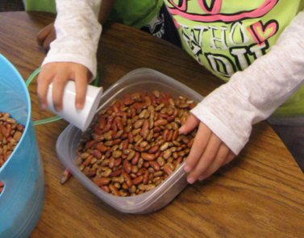
Capacity using dried beans and different sized containers

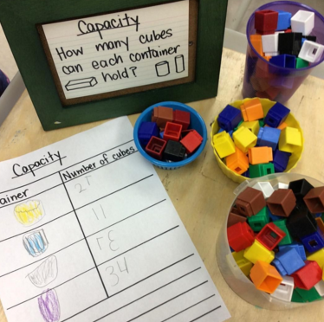
Capacity using cubes or blocks and different sized containers or tubs

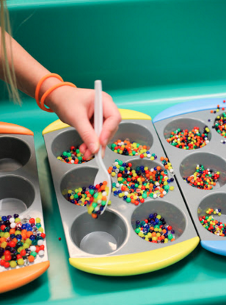
Capacity using cupcake trays and beads/marbles – whatever you already have at home

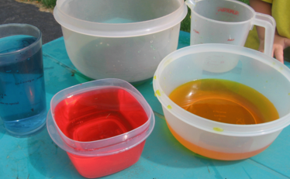
Capacity using water, coloured with food colouring – you don’t have to colour it but if you have some at home, then why not

