An Zú
Na h-ainmhithe
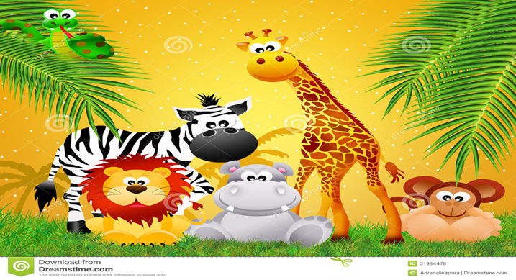

Sioráf – A Giraffe Séabra – A Zebra Síota – A Cheetah
Moncaí – A Monkey Nathair – A Snake Tíogar – A Tiger

Leon – A Líon Eilifint – An Elephant Fia – A Deer

Tá siad go h-álainn – They are lovely.

Tá siad go h-uafásach –They are terrible/awful.

Is maith liom an ……- I like the ……...
Ní maith liom an…… - I don’t like the …….
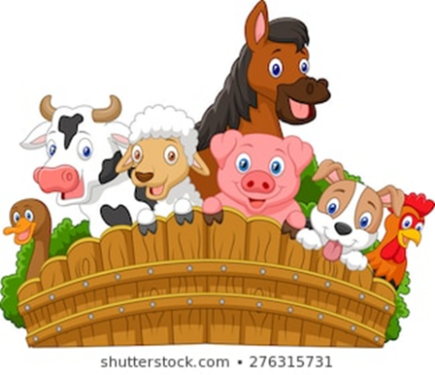
Ar an bhFeirm – On the farm
Na h-ainmhithe
Madra – a dog cat –a cat bó – a cow
Caora – a sheep uan – a lamb

Muc – a pig cró na muc – a pigsty
‘Tá an seomra cosúil le cró na muc’!
Capall – a horse asal – a donkey searrach – a foal
Lacha – a duck cearc – a hen Sicín – a hen

AN MAITH LEAT?
Cáis = cheese Prataí = potaátoes íogairt = yoghurt
milseáin = sweets seacláid = chocolate bainne = milk
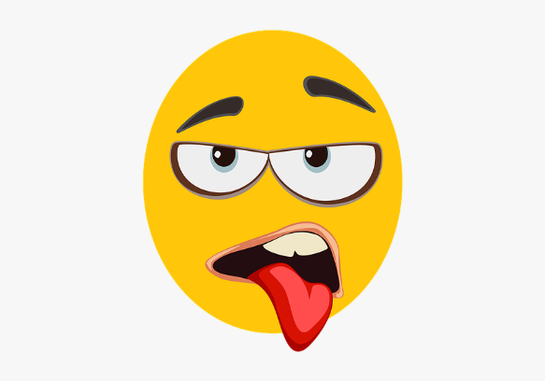
Ceist: An maith leat … cáis? (Do you like …cheese?)
Freagra: Is maith liom ….cáis. (I like … cheese)
Freagra: Ní maith liom…cáis. (I don’t like …. Cheese)
Freagra: Is fuath liom …cáis. (I hate ….cheese)
Ceist: An maith leat ….bainne? (Do you like …milk?)
Freagra: Is maith liom ….bainne. (I like … milk)
Freagra: Ní maith liom…bainne. (I don’t like ….milk)
Freagra: Is fuath liom …bainne. (I hate ….milk)

Note: An maith leat – do you like / Is maith liom – I like
Ar mhaith leat – would you like / Ba mhaith liom – I would like

